Design Your UI To Display The Temperature, Humidity

|  |  |
| --- | --- |
| Team Id | PNT2022TMID01003 |
| Title | Hazardous Area Monitoring for Industrial Plant using IoT |

**In MIT App Inventor**

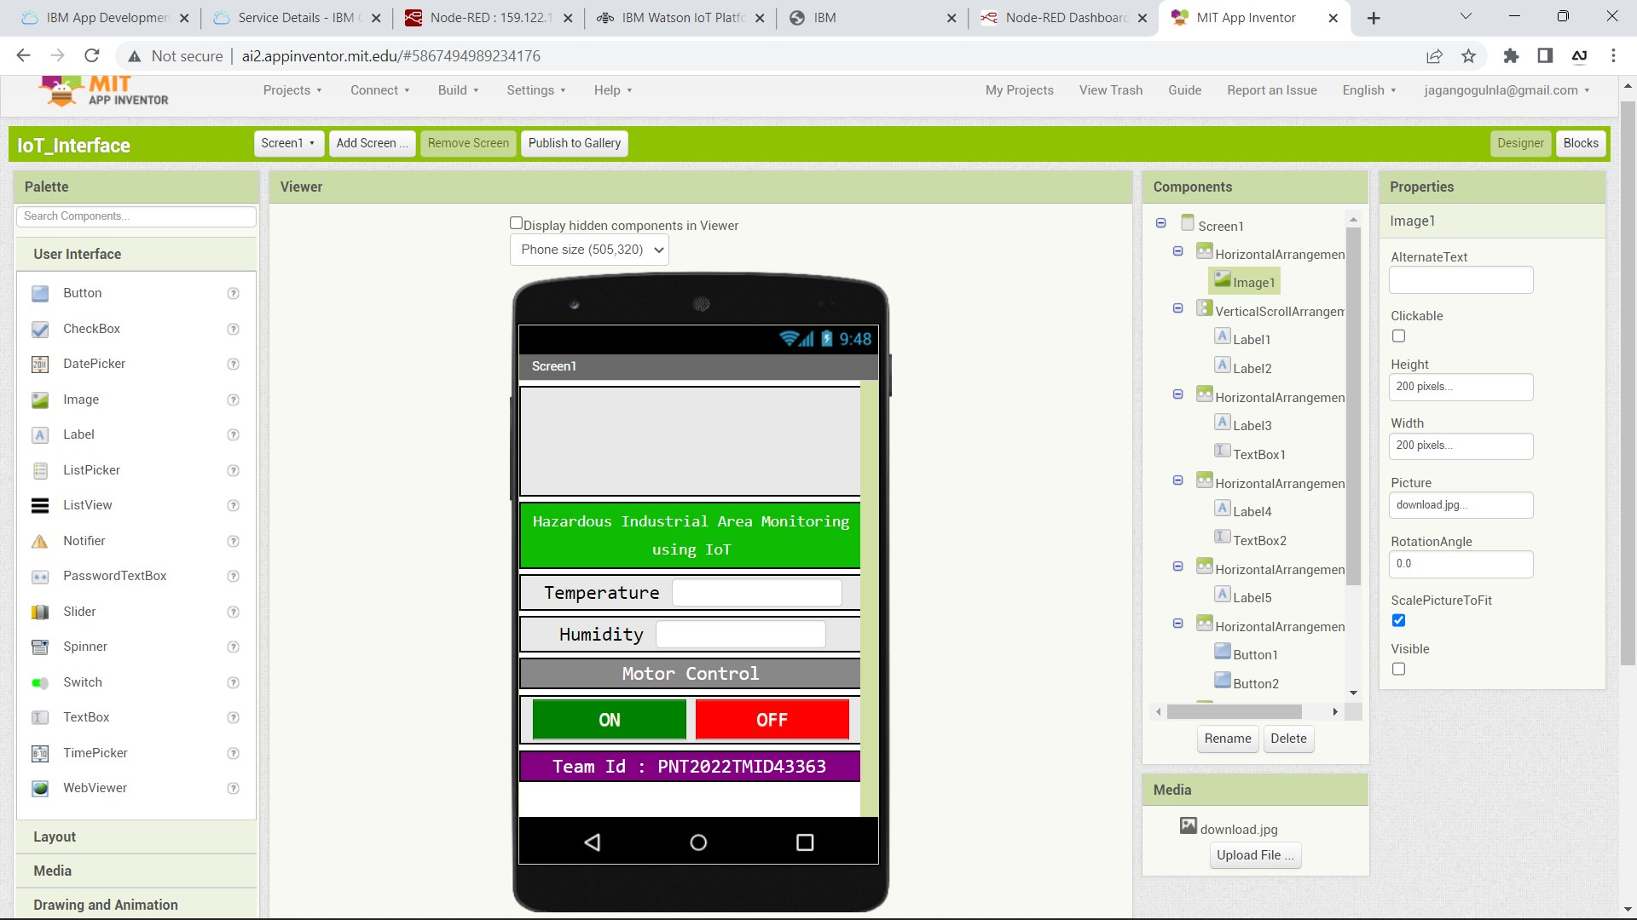

**In Mobile Phone**

